# UNIVERSITY OF MUMBAI



## Master of Computer Application

Mini Project Report On

## MBA CET PREPARATION APP

Submitted by

**Saurabh Gupta – 39**

## (SEMESTER - 2)

Year 2021-22

Under the Guidance of Prof. Shrishendu Maitra.

Faculty In-Charge

## Acknowledgement

While preparing the project report, it has been our Endeavour to present the subject and the execution in simple and coherent manner to those who wish to refer it for enhancement or improving the existing features. The knowledge that we have gathered during the study of relevant literature for understanding our project, planning of details and suitable software platform by itself and acknowledgement to the industry zeal and technical competence of those many individuals who have contributed to it with profound gratitude, we wish to acknowledge them.

We sincerely thank Thakur Institute of Management Studies, Career Development and Research for training us in the MCA course. We express our deep gratitude to our honourable Director **Dr.Vinita Gaikwad** and also express our deep gratitude to our internal guide’s **Prof. Shrishendu Maitra**.

|  |  |  |  |
| --- | --- | --- | --- |
| **Sr No** | **Modules** | **Detailed Contents** | **Page** |
| 1. | Introduction | * Introduction of Project(SRS) * Problem Definition * Objective of Project * Scope of Project | 1 |
| 2. | App Develop Life Cycle | * Methodology * Spiral Model | 4 |
| 3.  3(a) | Requirement and Specification  Application Design | * Software/ Hardware Requirement Specification * Software Requirement * Hardware Requirement * Gantt Chart * Use case Diagram * ER Diagram | 6 |
| 4. | Testing & Validation | * Test cases and Report | 9 |
| 5. | User Manual | * Method of Implementation * Forms and Output Screens | 12 |
| 6. | Conclusion | * Project Conclusion * Future Scope | 17 |
| 7. | References | * References | 18 |

# INTRODUCTION

## INTRODUCTION TO THE PROJECT:

MBA CET PREPARATION APP :- This app is developed for Educational Purpose, Where the students can login and prepare for mba cet 2022. Application is purely developed in android studio where database is created with help of google firebase. In this application student can get latest mba cet syllabus , notes , youtube video lecture without any adds , free mock test , last 5 year question papers and student have any doubt then there is option of contact us via whatsapp so student can directly ask his/her doubt at anytime and get solution.

The project aims and objectives that will be achieved after completion of this project are discussed in this subchapter.

The aims and objectives are as follows:

* + - Online MBA CET Preparation App
    - MBA CET Latest Syllabus You Can View
    - Student Get Free Notes
    - Get Youtube Video Lecture Without any adds
    - Last 5 Year Question Paper You get on this App
    - Student can give Free Mock Test
    - User can direct contact on my whatsapp for any doubt

## PROBLEM DEFINITION:

Now a days student want to prepare for MBA CET exam but the big problem is from where the student will prepare for the exam. Nobody will give you proper full solution or proper guidance for MBA CET exam. This app is designed for the students who want to prepare mba cet at various sites .which is time consuming and loss of data. This app is one stop app for all the needed preparation for mba cet in a single app. This application is basically for those student who want to prepare/crack there MBA CET exam. This application provide you syllabus, lecture video, notes, previous year question paper, quize etc. Because of this application the student can easily get the content to study.

## OBJECTIVE:

The objectives of proposed system is as follows:

* MBA CET Preparation
* Saves time and cost.
* Facility to free mock test
* Get latest / updated syllabus 2022
* Subject wise youtube video lecture you get
* Easy to understand due to user friendly GUI.
* Lecture Notes can be viewed
* Easy to use.
* Student directly contact me via whatsapp at anytime
* Student get last 5 year question paper

## SCOPE OF THE PROJECT:

This application is developed for Educational Purpose,Where the students can login and prepare for mba cet 2022. The scope of this project is defined as follow:

* User can give free mock test
* Student can contact us via whatsapp at anytime for asking doubt .
* User can read notes a pdf formate
* User can view youtube video lecture subject wise
* User can view previous 5 year question paper with solution
* User can also view strategy video
* User can use all feature free

**2.APP DEVELOPMENT LIFECYCLE**

**METHODOLOGY**

**SPIRAL MODEL**

The spiral model is similar to the incremental model, with more emphasis placed on risk analysis.

The spiral model has four phases: Planning , Risk Analysis, Engineering and Evaluation.

A software project repeatedly passes through these phases in iterations (called Spirals in this model).

The baseline spiral, starting in the planning phase, requirements are gathered and risk is assessed.

Each subsequent spiral builds on the baseline spiral.

**Diagram of Spiral Model**

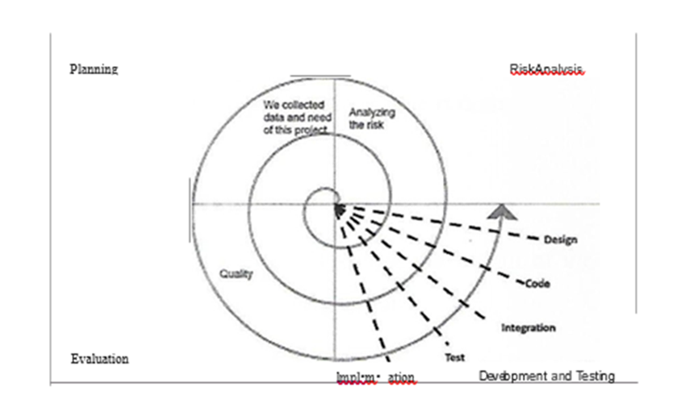

**Planning Phase**

Necessary Needs / Requirements were collected for making this project were done this initial stage called Planning Phase. SRS that is “Software Requirement Specification” is used.

**Risk Analysis**

In this phase while building the project a process is undertaken to find out the possible risks that can be faced a prototype is made and tested to find out any risk factors and if risk is detected what can be its alternate solutions to be implemented.

**Engineering Phase**

In This phase Software is built completely along with all possible testing over the built software. Hence software is developed and tested.

**Evaluation phase**

This is the final phase which allows the customer to test the project / software that has been developed till date before moving towards the next spiral.

**3.REQUIREMENT AND SPECIFICATION**

**Hardware and Software Requirements:-**

## HARDWARE REQUIREMENT:-

* **PROCESSOR-intel COREi5 RAM-8GB**
* **SYSTEMTYPE- 64bitOS**
* **MOUSE–Integrated**
* **KEYBOARD-Lenovo/2Keyboard**
* **PRINTER**

## SOFTWARE REQUIREMENT:-

* **Frontend–Android Studio**
* **Backend–FireBase**
* **Operatingstudio-Windows10**

**3(a).APPLICATION DESIGN**

## Gantt Chart :

## 

* 1. **Use Case Diagram:**

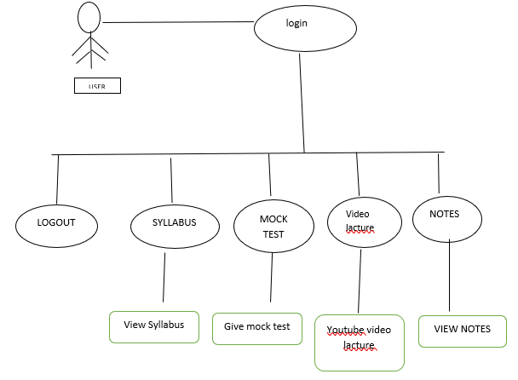

* 1. **Entity Relationship Diagram:**

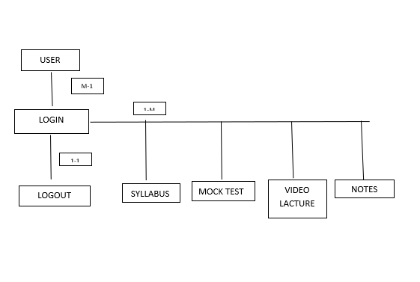

# TESTING & VALIDATION

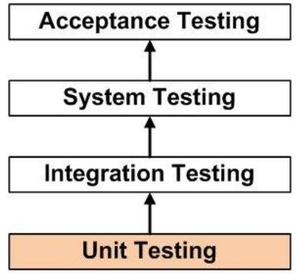

### Unit Testing

Unit testing is a level of software testing where individual units/ components of a software are tested. The purpose is to validate that each unit of the software performs as designed. Unit testing frameworks, drivers, stubs, and mock/ fake objects are used to assist in unit testing.

### Integration Testing

Integration Testing is a level of software testing where individual units are combined and tested as a group. The purpose of this level of testing is to expose faults in the interaction between integrated units. Test drivers and test stubs are used to assist in Integration Testing.

Integration testing is done by a specific integration tester or test team. Integration testing follows two approach known as ‘Top Down’ Approach and ‘Bottom Up ’ approach.

### System Testing

System Testing is a level of software testing where a complete and integrated software is tested. System Testing (ST) is a black box testing technique performed to evaluate the complete system the system's compliance against specified requirements. In System testing, the functionalities of the system are tested from an end-to-end perspective.

System Testing is usually carried out by a team that is independent of the development team in order to measure the quality of the system unbiased. It includes both functional and Non Functional testing.

### Acceptance Testing

Acceptance Testing is the process of testing the modified parts of the code and the parts that might get affected due to the modifications to ensure that no new errors have been introduced in the software after the modifications have been made. Regression means return of something and in the software field, it refers to the return of a bug.

**Test Case:**

|  |  |  |  |  |
| --- | --- | --- | --- | --- |
| **TEST CASE NAME** | **TEST CASE DESCRIPTION** | **TEST STEPS** | | **TEST RESULTS** |
| **STEPS** | **EXPECTED**  **RESULTS** |
| LOGIN | To verify email and password | Enter incorrect  email | Error | HIGH |
| Empty email  field | Error | HIGH |
| Empty password  field | Error | HIGH |
| Enter correct email &  Password | Message "Login  successful" | HIGH |

TESTING SCREENSHOOT

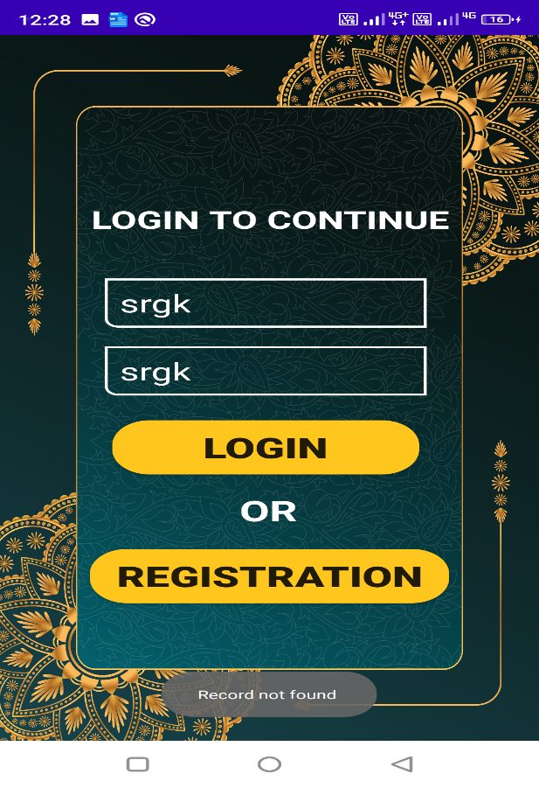

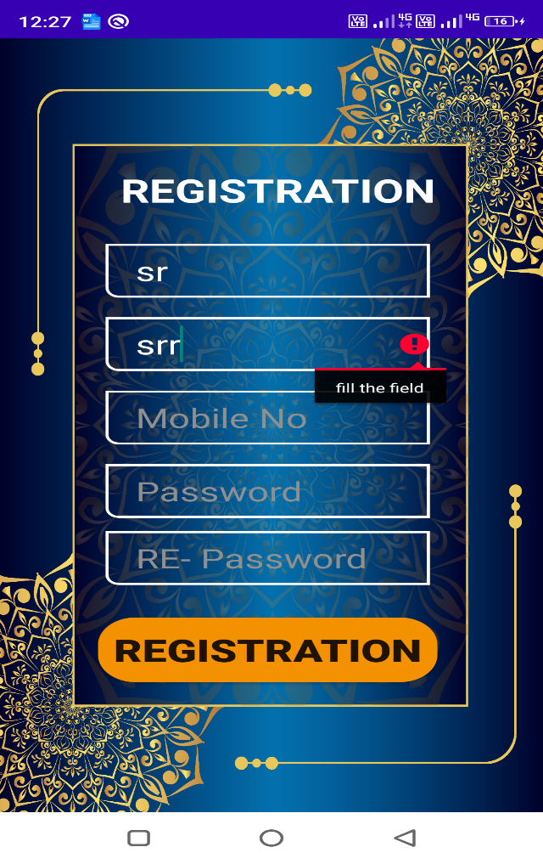

# USER MANUAL

**Splash Scrren Login**

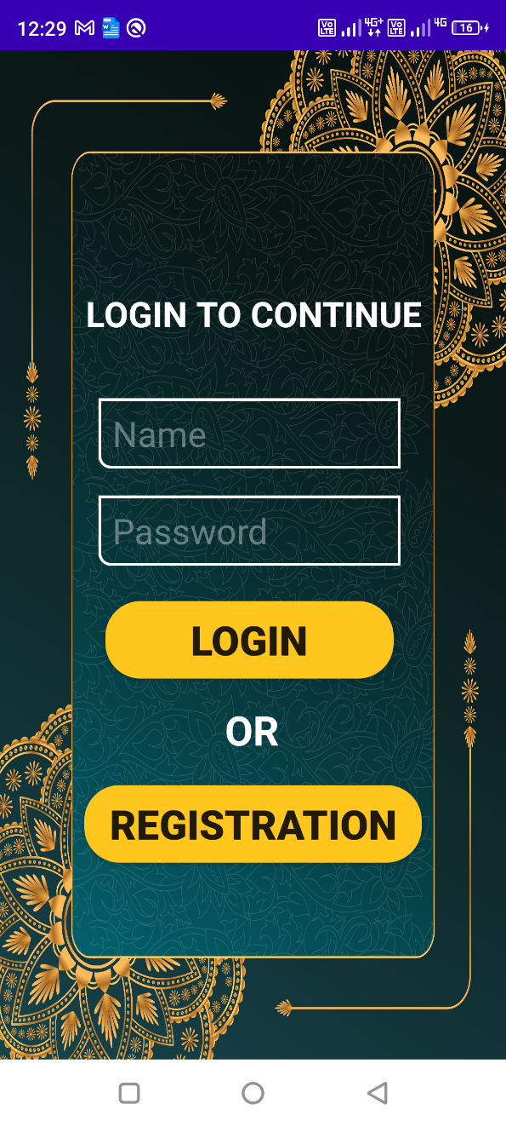 

**Registration MainScreen**

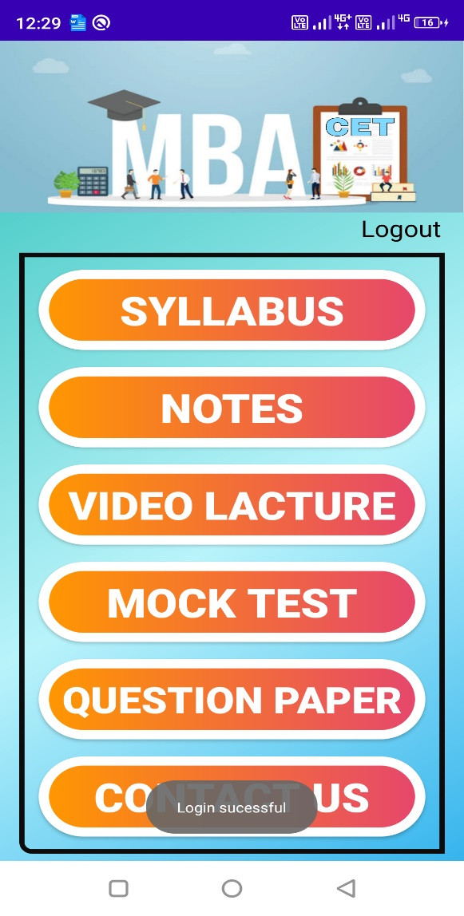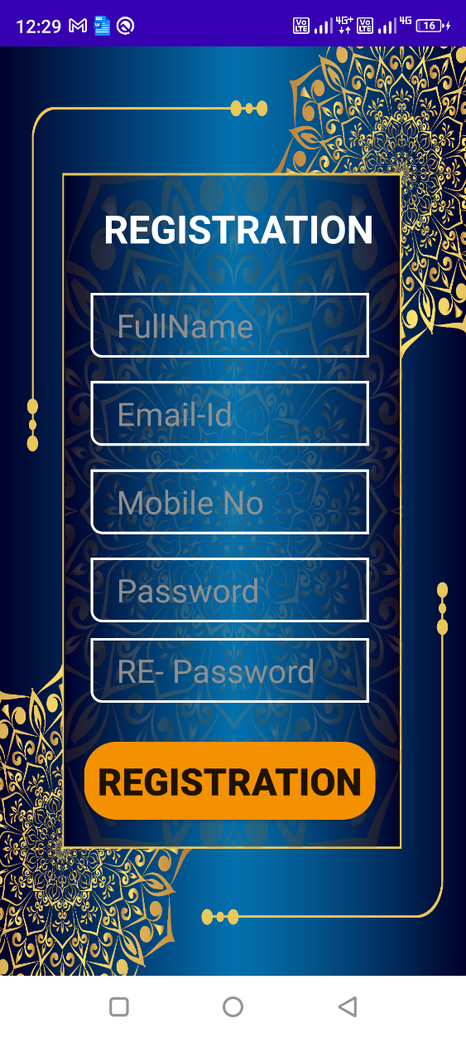

**Select video lacture subject Youtube video lacture**

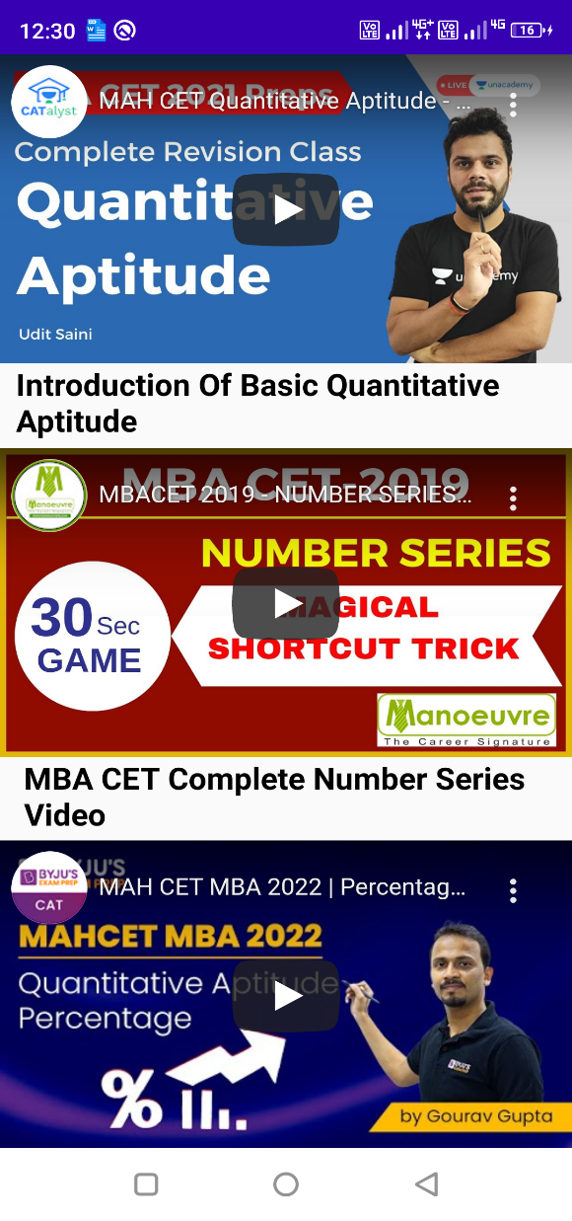 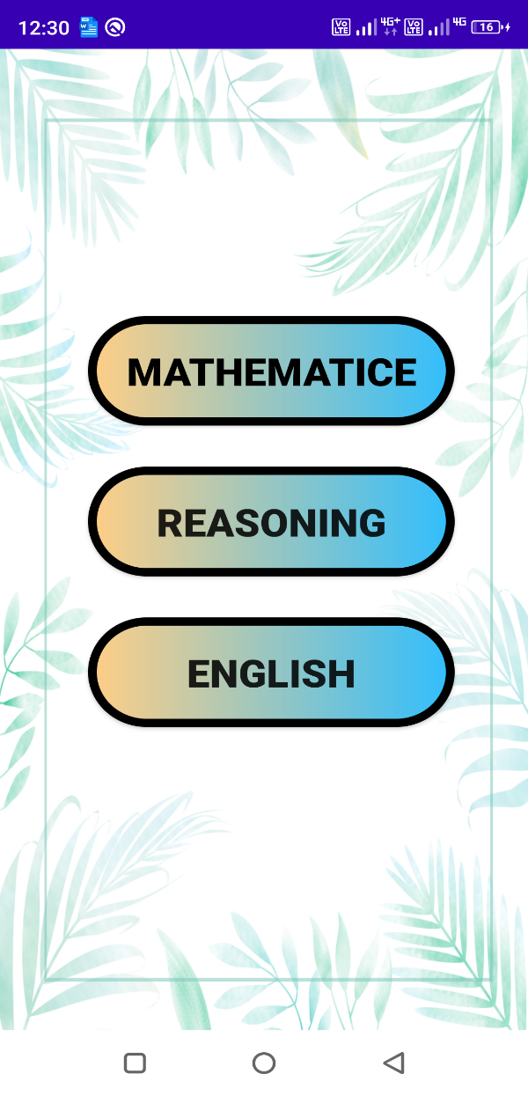

**Mock test Notes subjects**

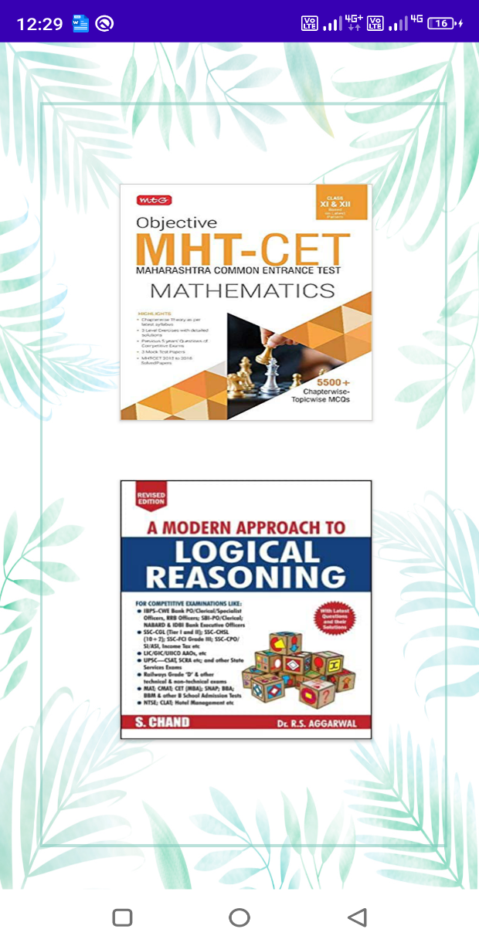 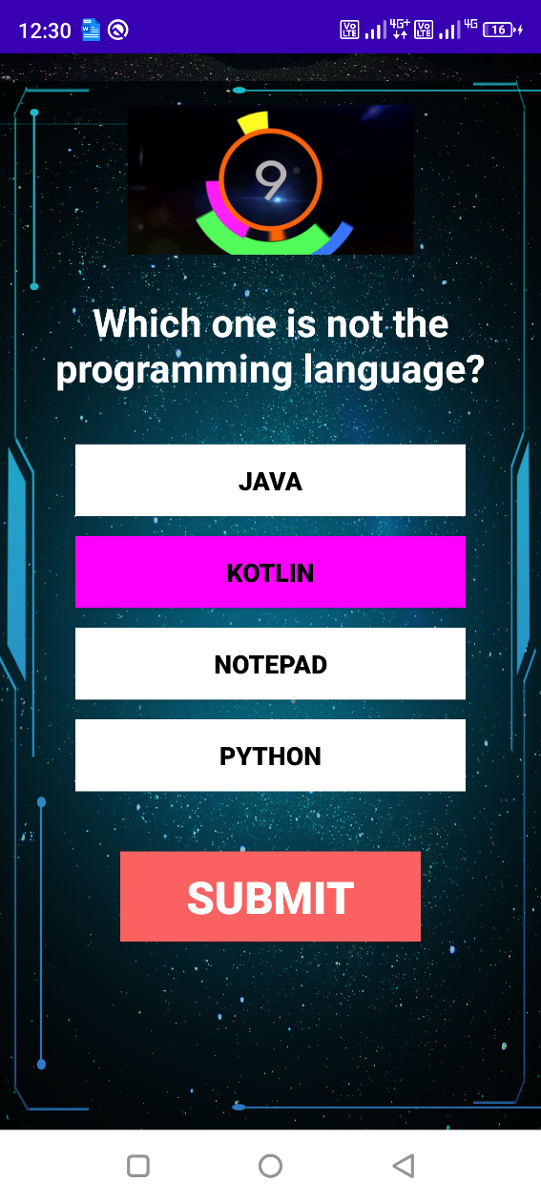

**PREVIOUS YEAR QUESTION Contact Us Via Whatsapp**

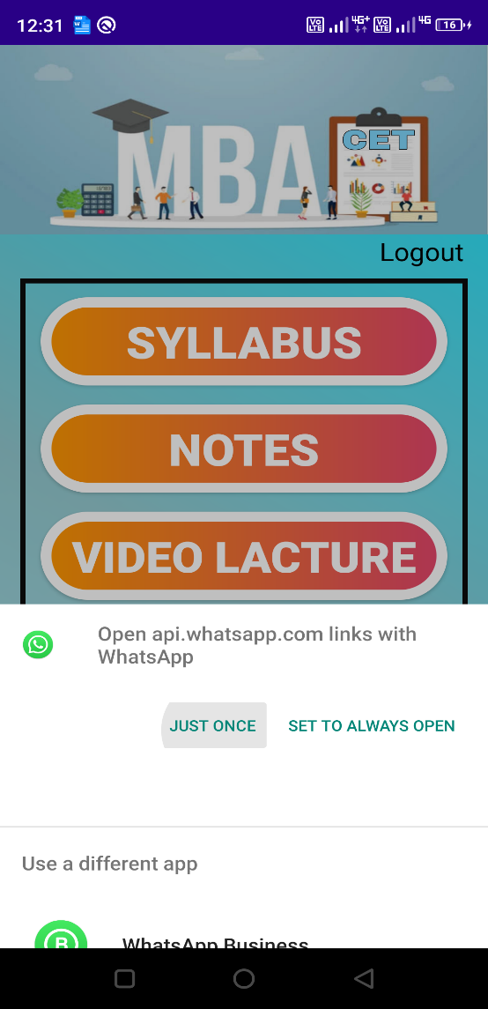 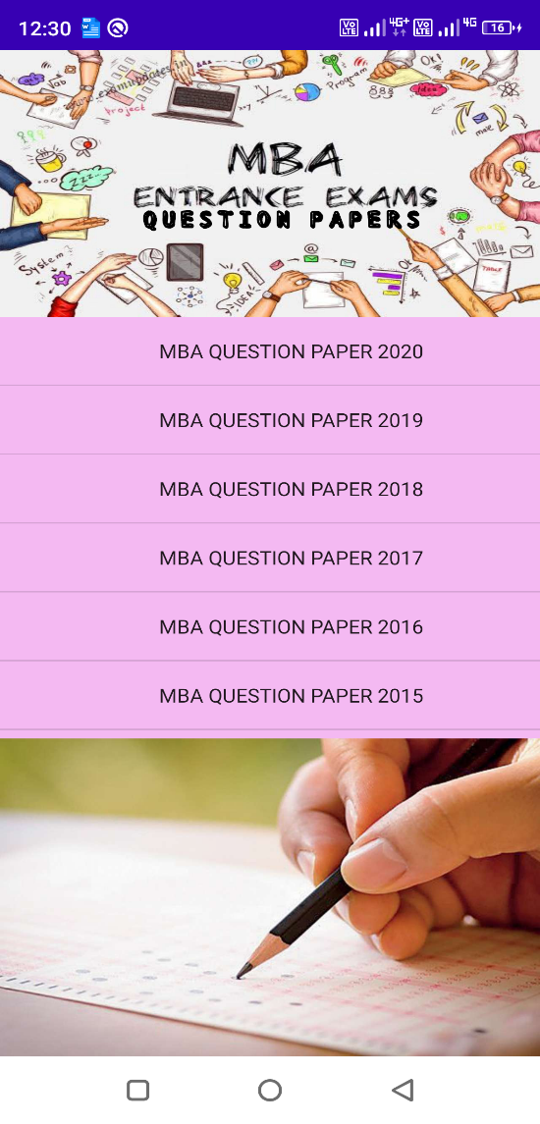

**CONCLUSION:-**

### Project Conclusion:

The developed App is successfully implemented. The App is successfully tested and also it provides nearly all requirements of user. The project being simple and flexible is running successfully. The main advantage of project is that it can be easily run by any user and also it is flexible enough.

“MBA CET Preparation” App developed for a User has been designed to achieve maximum efficiency and reduce the time taken to visit various website to for preparing mba cet 2022. In this application student can get latest mba cet syllabus , notes , youtube video lecture without any adds , free mock test , last 5 year question papers and student have any doubt then there is option of contact us via whatsapp so student can directly ask his/her doubt at anytime and get solution

### Future Scope:

* We will also introduce new features such as tab layout , chat system etc so more user can interact with us.
* In future we will cover all cet entrance exam
* Enhanced UI and Speed of app
* in future we will also made website also

.

# REFERENCES

1. <https://developer.android.com/studio>
2. <https://androidstudio.en.uptodown.com/windos>
3. <https://stackoverflow.com/>
4. <https://www.tutorialspoint.com/android/index.m>
5. <https://hackr.io/tutorials/learn-android-development>